VERKHOVNA RADA OF UKRAINE
MINISTRY OF INFRASTRUCTURE OF UKRAINE
THE UNION OF RAILWAY AND TRANSPORT CONSTRUCTION WORKERS OF UKRAINE
JSC «UKRZALIZNYTSIA»
INTERNATIONAL TRANSPORT FEDERATION

THE STATE UNIVERSITY OF INFRASTRUCTURE AND TECHNOLOGIES
UKRAINIAN UNIVERSITY OF RAILWAY TRANSPORT
UKRAINIAN STATE UNIVERSITY OF SCIENCE AND TECHNOLOGY

II International Scientific and Practical Conference
«Challenges and prospects of socio-economic
development of railway transport - UKRPROFZT 2021»

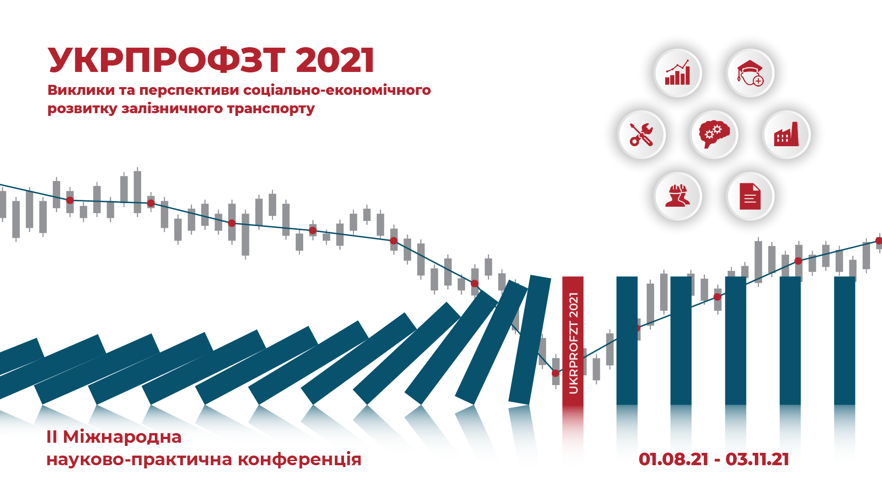

03 November 2021 р.
We invite you to take part in the work of the II International Scientific practical conference «Challenges and prospects of social Economic Development of Railway Transport - UKRPROFZT 2021», which should become a unique discussion platform for leading scientists, government officials and the business community to discuss new challenges posed by long-term transformation processes in the industry and changes in the institutional environment, and prospects for socio-economic development railway transport.

ORGANIZATIONAL COMMITTEE
Bubnyak Vadym - Chairman of the Union of Railway and Transport Construction Workers of Ukraine (Chairman of the Organizing Committee)
Yulia Hryshyna – Chairman of the Temporary Investigation Commission of the Verkhovna Rada of Ukraine on Inspection and Assessment of JSC Ukrzaliznytsia, Chairman of the Subcommittee on Higher Education of the Verkhovna Rada Committee on Education, Science and Innovation, Doctor of Law.
Kovalev Artem – Chairman of the Subcommittee on River Transport of the Verkhovna Rada Committee on Transport and Infrastructure
Kubrakov Oleksandr – Minister of Infrastructure of Ukraine
Kamyshin Alexander - Acting Chairman of the Board of JSC Ukrzaliznytsia (by agreement)
Yuryk Ivan – acting Chairman of the Board of JSC «Ukrzaliznytsia» (by agreement)
Stephen Cotton – ITF General Secretary of International Transport Federation (by agreement)
SCIENTIFIC COMMITTEE
Braikovska Nadiya – Chancellor of the State University of Infrastructure and Technologies, Candidate of Technical Sciences (Chairman of the Scientific Committee)
Panchenko Serhiy – Chancellor of the Ukrainian State University of Railway Transport, Doctor of Technical Sciences
Pshinko Oleksandr – Acting Chancellor of the Ukrainian State University of Science and Technology, Doctor of Technical Sciences, First Vice-President, Head of the Eastern Research Center of the Transport Academy of Ukraine, Doctor of Technical Sciences.
SECRETARIAT
Head of the Secretariat
Yanovska Viktoriia – Head of the Department of Economics, Marketing and Business Administration, State University of Infrastructure and Technology, Director of the Public Union «Center for Railway Transport Research», Doctor of Economics.
Executive secretaries
Hnatyuk Oleksandr – Head of the Department of Organizational and Personnel Work of the Council of the Union of Railway and Transport Construction Workers of Ukraine
Tvoronovych Viktoriia – Associate Professor of Economics, Marketing and Business Administration, State University of Infrastructure and Technology, Candidate of Economic Sciences.
Pylypenko Olena – Associate Professor of Economics, Marketing and Business Administration, State University of Infrastructure and Technology, Candidate of Economic Sciences.
Nakalyuzhna Alina – Senior Lecturer, Department of Economics, Marketing and Business Administration, State University of Infrastructure and Technology
Ustilovska Anastasia – Scientific Secretary of the Public Union «Center for Railway Transport Research», Ph.D.

CONFERENCE FORM
Mixed format: online and offline
CONFERENCE CALENDAR
Acceptance of abstracts for printing in the collection of conference materials | 01.08 – 17.10.2021 р.
Acceptance of proposals for the draft resolution of the Conference | 01.08 – 21.10.2021 р.
Holding the Conference online  Access mode:  https://www.urm.media/ukrprofzt-2021/ | 27.10 – 02.11.2021 р.
Holding the Conference in offline format with broadcast in the videoconferencing system of The Union of Railway and Transport Construction workers of Ukraine | 03.10.2021 р.

WORKING LANGUAGES OF THE CONFERENCE
Ukrainian, English
CONFERENCE PROGRAM
We invite you to present the results of research and practical solutions on the topics of the Conference in the following sections:
1. Reforming JSC «Ukrzaliznytsia»: risks and opportunities for the state, business, personnel.
2. Improvement of collective-contractual regulation of social and labor relations.
3. Personnel loyalty (systems: remuneration, personnel motivation, occupational health and safety).
4. Effective use of social infrastructure facilities.
5. Corporate governance: current status and development prospects.

PUBLICATION OF CONFERENCE MATERIALS
Based on the results of the Conference, a collection of materials (abstracts) will be published.
Abstracts for publication in the Conference Proceedings:
- given in Ukrainian and English languages;
- not edited and printed in the author's edition;
- are not accepted for publication without notifying the author if the requirements for the preparation of materials are not met;
- should correspond to the theme of the Conference and their length should not exceed three pages;
- filed electronically from August 1, 2021 to October 17, 2021 (inclusive).

The file with abstracts is uploaded on the site – https://www.urm.media/ukrprofzt-2021/.
Before downloading, information about the author (a representative of the group of author) is provided, contacts are indicated.
Technical or other questions are waiting to e-mail – rail.ua.ecosystem@ukr.net
Printing abstracts in the collection of conference materials is FREE

REQUIREMENTS FOR ABSTRACTS
File name - surname (s) and initials of the author (s).
Example – «Ivanenko I.I., Petrenko P.P.»
1. Abstracts are submitted in Ukrainian or English.
2. Text editor: Microsoft Word, format *.doc або *.rtf.
3. The volume of abstracts is up to 3 pages, no page numbering.
4. Page settings:
- all fields – 2 см. paper sheet size – А4,
- orientation – book.
5. Interval between rows – 1.
6. Hat of abstract:
index JEL: font Times New Roman 14 pt, align text to the left.
surname and initials of the author (highlighted, italics), position and place of work / study (italics), scientific degree, academic title (italics): font Times New Roman, font size – 14 pt, align text to the left.
ABSTRACT TITLE: font Times New Roman, bold, in capital letters, font size 14 pt, align text to the center.
7. Annotation: typed from a paragraph of 1,0 cm, no more than 3 lines, placed, font Times New Roman, size - 12 pt, italics, text alignment in width, performed in the language of the main text.
8. The main text is typed from a paragraph of 1,0 cm, font Times New Roman, size - 12 pt, justified alignment.
9. The text of the abstracts should contain:
- problem statement,
- presentation of the main research materials,
- conclusions.
10. The material should be presented concisely, consistently, stylistically competently. Terms and designations must comply with applicable standards.
11. Formulas: use the Microsoft Word formula editor. The formula is centered.
12. Illustrations (maximum - one): arrange in the text, aligning the captions (Fig. 1. Scheme ...) in the center. Illustrations should be clear and contrasting.
13. Tables (maximum - one) should be arranged in the text, font Times New Roman, size - 12 pt, above the table, mark its serial number (Table 1), italics, right alignment, under which the table name should be placed, bold, center alignment.
14. Words and phrases: Abstract, Problem statement, Main research materials, Conclusions - Times New Roman font, italic, bold. Literature: up to five sources. Reference and literature, respectively, in the text in brackets [ ].

EXAMPLE OF ABSTRACTS
JEL …

Ivanenko І.І., Associate Professor of the Department of ... State University of Infrastructure and Technology, Ph.D., Associate Professor

THE INFLUENCE OF CORPORATE GOVERNANCE ON THE RESULTS OF THE COMPANY'S ACTIVITY
Abstract: Key factors have been identified ...
Formulation of the problem. In a constant search for economic compromise ...
Basic research materials. Good corporate governance contributes significantly to the success and sustainability of a business ...
Conclusions. Research results show that ...

LITERATURE

1. Berardino D. Corporate governance and firm performance in new technology ventures. Procedia Economics and Finance, 39, 2016, pp. 412–421.

The number of full-time conference participants
is LIMITED

Conference participants pay their own travel, accommodation and other expenses

There is no organizational fee for participation in the Conference
CONTACTS
Mailing address:
buiding. 19, str. I. Ogienko, Kyiv-49, 03049, Ukraine
State University of Infrastructure and Technology

e-mail: rail.ua.ecosystem@ukr.net

web-site: https://www.urm.media/ukrprofzt-2021/

mobile phone: +38 044 591 51 21, +38 095 837 60 12

